# IDS 564: Social Media and Network Analysis

Lab 5: Link Prediction

Solution 1: Viola Plot for ‘fblog’ data

Solution 2: Viola plot for Huge Library predictions

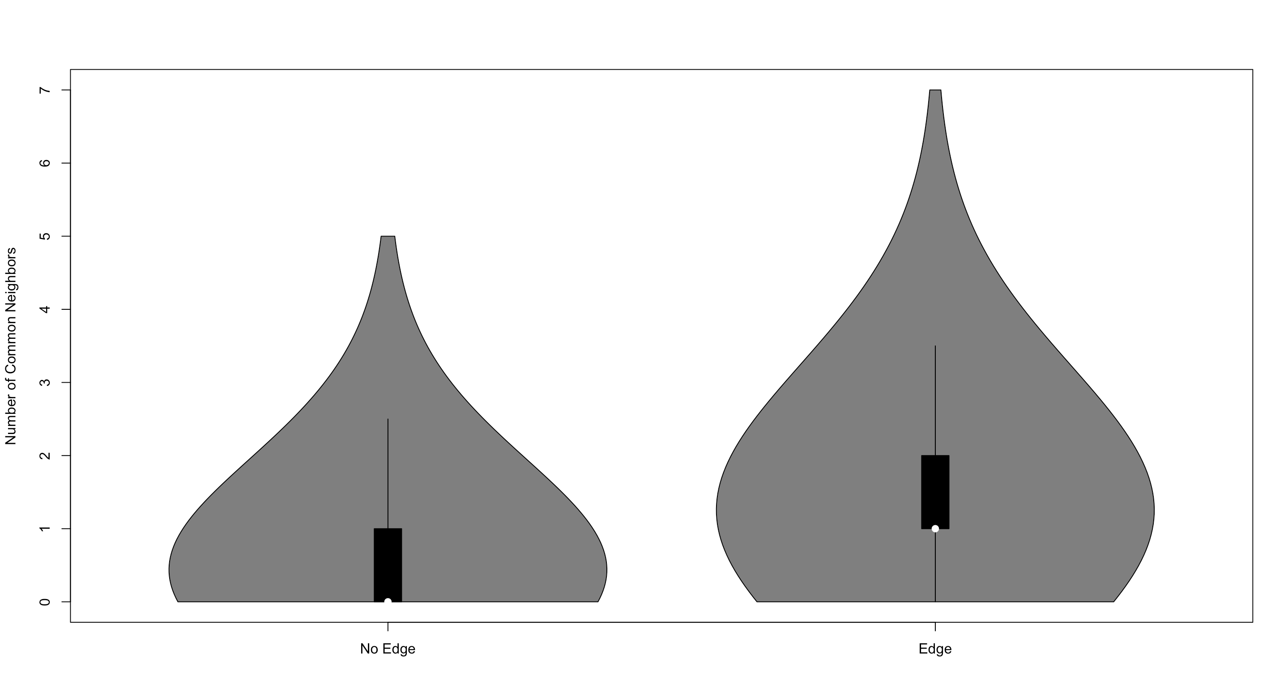

Solution 3:

Solution 4:

Solution 7:

